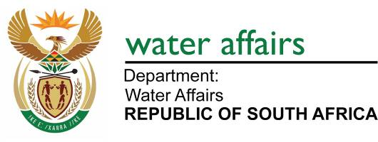

WESTERN CAPE WATER SUPPLY SYSTEM
RECONCILIATION STRATEGY

Status Quo Report

December 2009

TABLE OF CONTENTS

Page No

1. Introduction 2
1.1. Background 2
1.2. Purpose of this Report 2
2. SUMMARY OF 2007 reconciliation strategy study 3
2.1. Water Requirements 3
2.2. Water Conservation/Water Demand Management (WC/WDM) 4
2.3. Supply Side Interventons 4
2.4. Reconciliation Scenarios 5
2.5. Public Participation during the Study 6
2.6. Recommendations 6
2.7. Approval of Reconciliation Strategy Study Recommendations 7
3. PROGRESS WITH IMPLEMENTATION OF THE STRATEGY RECOMMENDATIONS UP TO
SEPTEMBER 2009 7
3.1. Establishment of the Strategy Steering Committee 7
3.2. Progress with WC/WDM 8
3.3. Progress with Studies 9
4. 2009 strategy update 10
4.1. Current Water Requirements 10
4.2. Climate Change 12
4.3. Removal of Invasive Alien Plants 12
4.4. Importance of Implementing the CCT's WC/WDM Strategy 12
4.5. Intervention Implementation Programme 13
4.6. Adjustments of the Strategy 14
4.7. Implications Highlighted by the Scenario Planning 17
4.8. Implementation of the Ecological Reserve 18
5. KEY MESSAGES 19
6. RECOMMENDATiONS 19

APPENDIX A: EXTENT OF THE WCWSS

APPENDIX B: BACKGROUND INFORMATION ON THE WCWSS

APPENDIX C: REPRESENTATION ON THE STRATEGY STEERING COMMITTEE

APPENDIX D: UPDATING OF WATER REQUIREMENTS

APPENDIX E: INTERVENTION IMPLEMENTATION PROGRAMME

- Introduction

  - Background

The Western Cape Water Supply System (WCWSS) serves more than 3 million people and provides water to the communities residing in the City of Cape Town (CCT) and in certain Overberg, Boland, West Coast and Swartland towns, as well as to irrigators along the Berg, Eerste and Riviersonderend rivers and to rural and stock-watering schemes in the West Coast, Swartland and Overberg areas. The main storage dams of the WCWSS are the Theewaterskloof and Voëlvlei dams (owned and operated by the Department of Water Affairs (DWA)); the Berg River Dam (owned by the Trans Caledon Tunnel Authority and operated by the DWA) and the Wemmershoek, Upper Steenbras and Lower Steenbras dams (owned and operated by the CCT). The figure in Appendix A illustrates the extent of the WCWSS and Appendix B gives background information on the operation of the WCWSS.

This area is the second largest contributor to the national economy and houses the third largest population concentration in the country. It is the economic hub of the Western Cape and is very important for the economic well-being of the province; with agricultural exports a significant component. Urban use within the CCT represents the largest water use from the WCWSS (63%) with approximately 32% of the total volume of water supplied being used by irrigators. The remaining 5% is taken up by other Water Services Authorities in the supply area.

The increase in the water requirements of the area served by the WCWSS is driven by population growth, as well as strong economic growth within all sectors. This necessitated the development of a strategy that could be used as a decision-support framework for making timeous and informed decisions on those interventions that should be implemented to meet the future water requirements. In early 2005, the then Department of Water Affairs and Forestry, as the custodian of the country's water resources, in partnership with the CCT, commissioned the Western Cape Reconciliation Strategy Study to facilitate the reconciliation of predicted future water requirements with supply from the WCWSS for a 25 year planning horizon.

The main objective of the Study was to provide recommendations for the development and implementation of interventions and actions required to ensure the ongoing reconciliation of the water supply and requirement and to offer a system for the continuous monitoring and updating of the Western Cape Reconciliation Strategy into the future.

The Western Cape Reconciliation Strategy Study was completed in June 2007.

  - Purpose of this Report

The purpose of this Summary Report is to:

- provide a short summary of the Western Cape Water Supply System Reconciliation Strategy Study that was completed in 2007, as well as the main recommendations from the study,
- give an overview of the progress made in the implementing of the recommendations of the Strategy,
- set out the updates to the Strategy, and
- list the updated recommendations.

- SUMMARY OF 2007 reconciliation strategy study

  - Water Requirements

The highest recorded unrestricted water use within the WCWSS area to date is 499 million m³/a in 1999. Water requirements of this magnitude have not occurred since then, primarily as a result of the imposition of water restrictions during the droughts in 2001 and 2004, and the positive impact of the implementation of water conservation and water demand management interventions by the CCT. The sectoral water use pattern in the WCWSS for 2006 was as follows:

Urban: 310 million m³/a (67% of the total)
Irrigation estimated: 154 million m³/a (33% of the total)
TOTAL 465 million m³/a

Various future water requirement scenarios were developed, using a model which was developed for the CCT as part of their study entitled “City of Cape Town: Review of the Long-Term Urban Water Demand” (completed in 2006). The model was based on several parameters with the primary inputs being population and economic growth.

Two future water requirement scenarios were developed for the Western Cape Reconciliation Strategy Study using the CCT model. These scenarios did not take account of future water conservation and water demand management measures, as these are included as interventions that could be selected to reduce the future water requirement.

The “High Water Requirement” scenario was based on high economic and high population growth rates, which translated to an average water requirement growth rate of 3% per annum. In this scenario, the total system requirements grew from 502 million m³/a in 2006, to 935 million m³/a in 2030. The “Low Water Requirement” scenario was based on low economic and low population growth rates. In this scenario the total system requirement grew from 465 million m³/a in 2006 to 670 million m³/a in 2030. This translated to an average growth in water requirement of 1.4% per annum. Figure 1 shows the High and Low Water Requirement scenarios as determined in the Reconciliation Strategy Study.
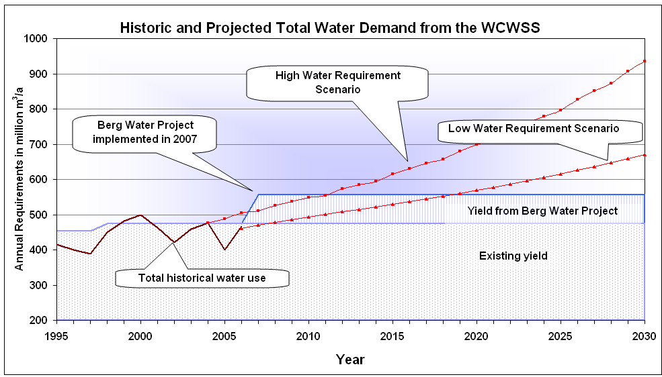

Figure 1: High and Low Growth Water Requirement Scenarios
Based on the High Water Requirement scenario, an intervention would have to be implemented by 2011 in order to ensure the ongoing reconciliation of supply and requirement.

  - Water Conservation / Water Demand Management (WC/WDM)

In 1999, the CCT initiated their “Integrated Water Resources Planning Study”, the outcome of which clearly indicated that WC/WDM interventions would be the most feasible for reconciling water requirement and supply. In 2001, the CCT developed a WC/WDM Policy and Implementation Strategy. It was this action, together with the submission of the CCT’s Water Services Development Plan, that led the then Minister of Water Affairs to approve the construction of the Berg Water Project as a parallel process to the CCT implementing WC/WDM measures. Institutional restructuring and other competing priorities in the CCT between 2002 and 2004 impacted on the implementation of the WC/WDM initiatives. However, in 2004 a 10-point strategy, including both output and input goals, was developed in partnership with the DWAF to augment the original 2001 WC/WDM strategy, including an 8-year budget, for implementation from 2005. However, the 2004/05 drought delayed completion of the strategy, with the focus being shifted to drought mitigation measures. The WC/WDM strategy was revised in 2006 and it was this revised strategy that was included in the WC Reconciliation Strategy Study, targeting a saving of approximately 44 million m³ by 2014/15, and this is referred to as the 8-year programme. It was found during the course of the study that further potential for savings existed over and above the 8-year plan.

  - supply side interventions

As the implementation of large projects can take up to ten years or more from feasibility study to completion, it is essential that potential future sources of supply be identified and investigated as soon as possible, and for the following reasons:

- A feasibility study may show that one or more of the identified interventions are not viable.
- The CCT and other water service providers need to be able to plan future related bulk infrastructure for the conveyance and treatment of water.

Given the fact that the WCWSS is an integrated system, there is no specific supply intervention which would need to be implemented first in order to reconcile supply and requirement over the longer term. There are therefore a number of interventions which could be studied and implemented in parallel, if proven feasible. The Reconciliation Strategy Study went through a selection process to identify the most favourable interventions or groups of interventions to meet possible future water requirement scenarios. These include, inter alia, surface water schemes, groundwater schemes, the re-use of water, the desalination of seawater and the removal of alien invasive plants.

To approximate a common base of information, all identified interventions were initially evaluated in terms of cost, socio-economic and environmental considerations. The time required to implement each intervention was considered and a detailed likely implementation programme for each intervention was drafted and reviewed. Public input was then obtained on additional interventions and the potential list of all interventions was amended accordingly.

A workshop was held where a widely representative, multi-stakeholder group took part in the screening process and helped eliminate unacceptable interventions. Overall, 66 interventions were discussed and the participants agreed to screen out 19.

  - Reconciliation Scenarios

A scenario planning process was used to identify, evaluate and assess alternative groupings and phasing of interventions so as to determine the most appropriate combination of interventions that could be implemented to reconcile water supply and requirement in the WCWSS, up to 2030. The objective was not to select one "favourable scenario" but to identify which interventions should be studied further to allow consideration of a range of possible scenarios. This would allow the DWA, the CCT, and other stakeholders, the maximum amount of flexibility in making informed decisions on which interventions to implement after the Berg Water Project, and beyond. The outcome of the process was a list of interventions that should be studied to feasibility level by specific dates, including timelines and the responsible organisations.

The list of the interventions which were identified as probably feasible to increase the available supply is given in Table 1.

Table 1: Possible interventions to increase the water resource
Intervention | Study Level  Required
GROUNDWATER
TMG Aquifer development | Feasibility
Cape Flats Aquifer development | Feasibility
Newlands Aquifer development | Pre-feasibility
West Coast Aquifer Recharge (Langebaan) | Pre feasibility
SURFACE WATER
Voëlvlei Phase 1 | Update feasibility
Michell's Pass Diversion | Pre-feasibility/Feasibility
Upper Wit River Diversion | Pre-feasibility
Raising Steenbras Lower Dam  (including pre-feasibility of Upper Campanula Dam) | Pre-feasibility
Lourens River Diversion Scheme (as linked to Raising Steenbras Lower) | Update Pre-feasibility
Upper Molenaars Diversion | Pre-feasibility
WATER RE-USE
Water re-use | Pre-feasibility
DESALINATION
Seawater desalination | Implementation of a pilot desalination plant
OTHER INTERVENTIONS
Invasive Alien Plant Clearance | Ongoing

The scenario planning process was utilised to inter alia assess the following:
• The benefits of implementing WC/WDM;
• The implications of implementing the ecological Reserve for existing water resources; and
• The implications arising from the possible effects of climate change.

During the scenario planning process various scenarios where considered. Each scenario had a specific objective, which could impact on the possible studies required, as well as the date when the DWA and/or the CCT should commence the implementation process.

  - Public Participation during the Study

The Reconciliation Strategy Study was designed to facilitate input from stakeholders and the public. Four newsletters giving feedback on progress with the Study and inviting feedback were distributed to a mailing list of Interested and Affected Parties. In addition, four public meetings were held at different locations in the supply area of the WCWSS. Presentations on the progress of the Reconciliation Strategy Study were also made to the Breede and Berg CMA Reference Groups on a number of occasions. A submission was also made to the Portfolio Committee of the CCT in order to obtain their support for the Reconciliation Strategy.

  - Recommendations

The following primary recommendations were made by the WCWSS Reconciliation Strategy Study which was completed in June 2007. The responsible organisation identified to undertake the recommendation is given in brackets.

a) Implement the City of Cape Town 8-year WC/WDM Strategy and Programme (CCT)

b) Determine the potential of additional longer-term WC/WDM interventions to be implemented beyond the existing 8-year strategy (CCT).

c) Complete the Feasibility Level Study of the TMG Aquifer (CCT)

d) Proceed with a Feasibility Level Study of:
- the Voëlvlei Augmentation (DWA)
- the Michell’s Pass Diversion (DWA)
- the Lourens River Diversion (CCT)
- the Cape Flats and Newlands Aquifer development (CCT)

e) Proceed with a Pre-feasibility Level Study of:
- the Molenaars River Diversion (DWA)
- the Upper Wit River Diversion (DWA)
- the further phases of the Palmiet Transfer Scheme (raising of Steenbras Lower Dam and implementing Campanula Dam on the Palmiet River) (DWA)
- the further phases of the Voëlvlei Augmentation (DWA)

f) Implement a Pilot Seawater Desalination Plant (CCT)

g) Establish a Strategy Steering Committee for the WCWSS (DWA)

  - Approval of Reconciliation Strategy Study Recommendations

Following the completion of the Reconciliation Strategy Study, the Strategy, along with its conclusions and recommendations, was presented to various organisations and authorities, including the DWA and the CCT. The Strategy was formally accepted by the DWA and the CCT in May 2007. Table 2 below lists the organisations/ forums to which the Strategy was presented and the dates on which they formally accepted or approved the recommendations of the Strategy.

Table 2 Presentation and Approval Dates of the Strategy
Organisation/Forum | Date Presented | Recommendations accepted/approved
Berg CMA Reference Group | April 2007
Technical Managers (Water Services) of the CCT | April 2007
Western Cape Provincial Liaison Committee | 25 April 2007
CCT’s Utility Services Portfolio Committee |  | 7 May 2007
DWA Water Resource Functional Management Committee |  | 15 May 2007
CCT’s Mayoral Committee |  | 16 May 2007
CCT Council |  | 25 May 2007

- PROGRESS WITH IMPLEMENTATION OF THE STRATEGY RECOMMENDATIONS up to september 2009

  - Establishment of the Strategy Steering Committee

One of the recommendations of the Reconciliation Strategy Study was that a Strategy Steering Committee (SSC) should be formed with a clearly defined mandate and scope of work.

The objectives of the SSC are:
• to ensure and monitor implementation of the recommendations of the WC Reconciliation Strategy,
• to update the Strategy to ensure that it remains relevant, and
• to ensure that the Strategy, its recommendations and progress with the implementation are appropriately communicated to all stakeholders.

The SSC was constituted with membership from the main users and institutions in the area. See Appendix C for the full list of members as well as the ToR for the Committee.

The following meetings were held:
- Meeting 1: 19 September 2007: The members were given a presentation on the background, conclusions and recommendations of the Reconciliation Strategy Study.
- Meeting 2: 18 March 2008: The Terms of Reference for the SSC, representation on the SSC and appointment of an Administrative and Technical Support Group was discussed by the SSC. The SSC also reviewed the progress which was made on the implementation of the recommendations contained in the Reconciliation Strategy Study.
- Meeting 3: 18 September 2008: The purpose of the meeting was specifically to confirm the Terms of Reference for the Steering Committee, to confirm the representation on the Committee, to review the updated historic water requirements and to receive presentations on the progress made with the implementation of the Reconciliation Strategy’s recommendations.
- Meeting 4: 11 March 2009: The meeting considered the re-use of water as a strategic source to augment the water supply to the WCWSS and received a presentation on climate change from Professor Hewitson from the Climatology Department of the University of Cape Town.
- Meeting 5: 17 September 2009: At this meeting current and future water requirements were reviewed and updated scenario planning results were presented and approved.

An Administrative and Technical Support Group (Support Group) was formed to support the SSC. The Support Group consists of representatives from the DWA’s National Office (Directorate of National Water Resource Planning and Options Analysis), the DWA Western Cape Regional Office and the CCT (Department of Bulk Water Supply and WC/WDM). The Support Group meets between the SSC meetings to ensure that the recommendations of the strategy and committee are implemented. Milkwood Communications (Pty) Ltd was appointed by the Department in July 2008 to provide administrative and technical support to both the Support Group and the SSC.

  - Progress with WC/WDM

During the finalisation of the Reconciliation Strategy Study, the CCT revised and extended their 8-year WC/WDM Strategy to be a more comprehensive 10-year Strategy extending from 2007/2008 through to 2016/2017. The 2006 draft WC/WDM strategy and 8-year programme, upon which the Reconciliation Strategy was based, targeted a water saving of approximately 44 million m³ by 2014/15. The approved 10-year WC/WDM Strategy targeted a saving of approximately 90 million m³ by 2016/2017. This is approximately 25% of the estimated high water requirement for the CCT in 2016/2017.

The CCT’s comprehensive 10-year WC/WDM Strategy and programme was approved by the Mayoral Committee in May 2007. A proposed budget of R759 million over a 10-year period was linked to the 10-year Strategy to enable the CCT to address the implementation goals set in the Strategy. At the end of June 2009, the CCT had implemented 2 years of its 10-year WC/WDM Strategy and programme. Over the last two years, the CCT has focussed on pressure management with an allocated budget of R17,2 million, an integrated water leaks detection and repair project with an allocated budget of R35,3 million, consumer education programmes, and the installation of flow devices and the implementation of water re-use schemes with an allocated budget of R57 million.

The CCT spent approximately R61.5 million in their 2007/08 financial year on the implementation of WC/WDM and have allocated approximately R85 million in their 2008/2009 financial year for WC/WDM. Whilst the CCT’s budget allocation, approval and expenditure has been in accordance (even exceeding) the approved WC/WDM Strategy, the Strategy implementation has not yet managed to curtail the water requirement to the 10-year Strategy’s stated target of 0% growth over the first 6 years, with the CCT’s water requirement currently still growing at approximately 2.5% per annum.

The increase in the CCT’s water requirement may be as a result of a higher economic and population growth rate than what was assumed in the “High Water Requirement” Scenario. It may also be due to inaccurate estimates of the potential savings associated with the WC/WDM interventions identified in the CCT’s approved WC/WDM programme. There is a need for the CCT to develop a monitoring programme as part of its implementation strategy in order to measure the impact of the WD/WDM measures. The indications are that, in order to obtain the required savings identified in the Strategy, the proposed monitoring programme will have to be supported by an increase in human resources.

Drakenstein Municipality’s water requirement in 2009 was 11 347 Ml. This figure is significantly lower than the projected water requirement for 2009 of 25 368 Ml. This saving of 14 021 Ml/year can be attributed to Drakenstein’s effective implementation of their WC/WDM strategy, which included installing a pressure management system. The present (2008) unaccounted for water is 15%, whereas in 1999 it was 43%. Drakenstein Municipality has also successfully implemented a water leak detection and repair programme in Saron which significantly reduced the losses. The result of this programme is a saving of 412 kl/day or 150 000 m3/year, which equals a 23% saving on the annual water demand.

Stellenbosch Municipality has undertaken a number of successful WC/WDM initiatives in 2008/2009, namely pipe replacement, upgrading of bulk user meters, measures to increase efficiencies at their water treatment works and measures to reduce water consumption.

  - Progress with Studies

In the recommendations of the Reconciliation Strategy Study, a number of supply interventions were identified as possible future water augmentation schemes that could be implemented after the Berg Water Project. In order to ensure that these supply-side interventions are available for implementation when required, the DWA and the CCT were assigned the responsibility of initiating feasibility and/or pre-feasibility level studies into these interventions.

All of the studies started later than was identified in the Strategy. However, the new programs have been taken into account in the updated Strategy and the net result is made clear in Section 4 of this Report.

3.3.1 DWA Studies
On 13 June 2008, the Western Cape Water Consultants, a joint venture between Ninham Shand, Kwezi V3 Engineers and Southern Waters Ecological Research and Consulting, were appointed by the DWA to undertake a study entitled: “Pre-feasibility and Feasibility Studies for Augmentation of the Western Cape Water Supply System by Means of Further Surface Water Development.”

The study will firstly involve an intensive preliminary investigation of the following six augmentation options identified in the WCRSS:
1. Michell’s Pass Diversion
2. First Phase Augmentation of Voëlvlei Dam
3. Further Phases of Voëlvlei Dam Augmentation from the Berg River
4. Upper Molenaars River Diversion
5. Upper Wit River Diversion
6. Further Phases of Palmiet Transfer Scheme

The contract duration is 36 months, commencing with an 18-month Preliminary Phase. In February 2010 a workshop will be held in order to determine which of the above six options are to be further investigated at pre-feasibility level and which options should be studied at feasibility level during the second phase of the project.

3.3.2 CCT Studies
The exploratory diamond core drilling of the TMG Aquifer has been completed. It is anticipated that the exploratory phase will be completed by the middle to end of 2010. The aim of the core drilling done during this contract was to obtain hydrogeological information that will inform the selection of a site to establish a pilot wellfield in the next phase of the study. The pilot wellfield development phase of the project will be completed by 2012/13, based on the assumption that the Environmental Impact Assessment is favourable.

The remaining feasibility studies identified as the responsibility of the CCT have yet to commence. It is the intention of the CCT to commence with Feasibility Studies for Water Re-use and for Desalination (including the installation of a pilot desalination plant) in its 2009/10 financial year and studies on the Cape Flats Aquifer and Lourens River development in the CCT’s 2010/11 financial year.

3.3.2 Other Municipalities

The West Coast District Municipality (WCDM) has recently completed a study into alternative water resources to augment their water supplies, and to focus particularly on the desalination of sea water. Various sources for additional water supply were identified, such as inter-basin transfers, desalination of sea water, artificial recharge of groundwater resources etc. The Saldanha Bay Municipality is also currently busy with two studies focussed on providing re-used water to industry at an industrial tariff.

The outcomes of these investigations will be factored in future updates of the Strategy.

- 2009 strategy update

  - Current Water Requirements

When the strategy was undertaken in 2006 there was uncertainty around the starting point for the High and Low Water Requirement curves. Given the fact that four years has elapsed since the imposition of water restrictions on the water users from the WCWSS, the starting point for the high and low water requirement curves was adjusted in 2008, based on the anticipated success of the WC/WDM measures implemented by the CCT. The projected growth rate upon which the high and low water requirement curves were based, were kept unchanged. It was assumed that the agricultural sector would grow into their full allocation from the WCWSS, where after the agricultural water requirement would remain constant. The water requirement growth rates for certain Overberg, Boland, West Coast and Swartland towns were assumed to be the same as was put forward in the 2007 Strategy Study. Figure 2 shows the actual urban and agricultural water requirements from the WCWSS.

Figure 2: Water Requirements from the WCWSS

A comparison between the actual water requirement from the WCWSS and the high water requirement curves developed during the Reconciliation Strategy Study (refer to Figure 3) shows that the actual water requirement falls just below the high water requirement curve. A more detailed description and explanation of the derivation of the actual water requirement is contained in Annexure D of this Report.

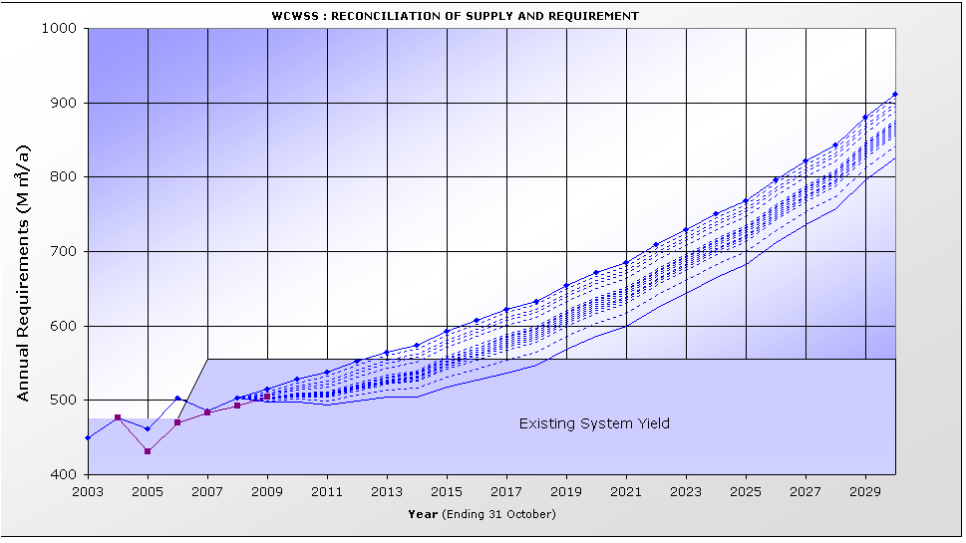
Actual

Figure 3: Actual and Projected water requirement from the WCWSS
The actual water usage from the WCWSS for 2009 amounted to approximately 505 million m³/a, compared to the available yield of the existing WCWSS (with the inclusion of the Berg Water Project) of 556 million m³/a.

  - Climate Change

The assumption used for climate change in the original study was that the available yield of future surface water interventions would negatively decrease by 15% over the next 25 years and that the yield of groundwater resources would decrease at 5% over the next 25 years. This would result in a reduction in yield of approximately 3 million m³/a for each year over the next 25 years (a total of approximately 75 million m³). During the SSC meeting held in March 2009, Professor Hewitson of the Climatology Department of the University of Cape Town confirmed that the scenario planning assumptions for the surface water interventions could be regarded as a realistic possible future scenario. According to Professor Hewitson, the climate change models predict that there could be a mean long-term drying trend in the Western Cape (with less certainty in the mountainous areas). It is further anticipated that more frequent intense rainfall events may occur.

Whilst there is a general acceptance that climate change is occurring, the long-term rainfall records at Wemmershoek and Steenbras dams do currently not show any evidence of significant short-term or long-term variance in annual rainfall patterns. This is unlike the City of Perth in Australia, which evidenced a significant decrease in rainfall and resultant runoff into their dams over the last 15 years.

It would be very costly to implement additional interventions to offset the potential decrease in yield as a result of climate change. Interventions should therefore only be implemented if proof of a long-term decrease in rainfall were to be found. It is, however, imperative that a strategy be developed, and that all the preparatory planning studies be undertaken now so that it would be possible for the responsible authorities to respond to climate change should it become a reality. In this regard it is important to monitor for any trend changes in rainfall and run-off and to understand the possible impacts of climate change on water requirements.

  - Removal of Invasive Alien Plants

The removal of alien vegetation is regarded as an important intervention to increase water availability. Studies undertaken for DWA have indicated that the effective clearing of alien invasive plants results in increased yields of existing and future water resource development options.

It is the intention of the SSC to work together with Working for Water (WfW) to develop reconciliation scenarios based on their programmes for the removal of alien invasive plants in the area, and that these scenarios feed into the broader reconciliation planning framework.

The increase in flows as a result of invasive alien plants cleared prior to 2004 should be reflected in the latest scheme yields which were determined as part of the Berg Water Availability Assessment Study (WAAS). These results should be reflected in future scenario planning when the WAAS results are incorporated into the reconciliation of supply and requirement.

  - Importance of Implementing the CCT's WC/WDM Strategy

The CCT’s revised 10-year WC/WDM Strategy is targeting a saving of approximately 90 million m³ by 2016/2017. This represents approximately 14% of the projected total WCWSS water requirement and approximately 25% of the projected CCT water requirement in 2016/2017. Should the CCT only achieve 50% success with the implementation of their WC/WDM Strategy and the current growth in water requirements continue, then a new augmentation intervention would be required by 2015, as is shown in Figure 4. However, no supply interventions can be available for implementation by that date, neither on a normal nor a “fast-tracked” programme. The successful implementation of WC/WDM is therefore critical if the risk of water shortages prior to the implementation of the next supply intervention is to be kept within acceptable limits. It is also important for the CCT to establish a monitoring programme to measure the impact of the WC/WDM interventions implemented.

Figure 4: Impact of a 50% success in WC/WDM on reconciliation of water supply and requirement

  - Intervention Implementation Programme

The implementation programmes for the Michell’s Pass Diversion, water re-use scheme and TMG is shown in Appendix E of this Report. The programme shown for the Michell’s Pass Diversion would be the same for the Voëlvlei Augmentation, the Upper Wit River Diversion and the Molenaars River Diversion, as these schemes are all currently being studied at pre-feasibility level by the DWA. An implementation programme for desalination can be assumed to be similar to the programme developed for a water re-use scheme. A comparative fast-tracked programme for these schemes is also shown in Appendix E. Fast-tracking an intervention could be achieved through either minimising approval processes, or running the environmental approval process and scheme design as a parallel process.

The construction programme for any of these interventions would be quite tight and is based on a number of construction activities being implemented in parallel, in order to ensure that the area does not run into serious water shortages.

  - Adjustments of the Strategy

In order to update the scenario planning undertaken as part of the Reconciliation Strategy Study, two scenarios were developed taking account of updated requirement scenarios as set out in section 4.1 of this report, as well as the current status of the pre-feasibility studies and implementation progress.

The following two scenarios were investigated:
- 2009 Reference Scenario: “High water requirement”, CCT WC/WDM strategy 100% successful, no climate change
- “Worst-Case” Scenario: “High water requirement”, CCT WC/WDM strategy 100% successful, with effects of climate change.

More possible scenarios exist between the 2009 Reference Scenario and the “Worst-Case” Scenario, but if solutions could be found for these two scenarios, all others should be covered. Should the water requirement follow the Low Water Requirement Curve and not the High Water Requirement Curve (refer to Section 2.1 of this Report), the required implementation date of interventions would be delayed and therefore more options for implementation would be available to select from.

4.6.1 2009 Reference Scenario (“High water requirement”, WC/WDM 100% successful, no climate change)

The 2009 Reference Scenario assumes that the CCT is able to achieve the WC/WDM targets it has proposed for the remaining 8 years of the approved 10-year WC/WDM Strategy and Programme. Under this scenario the requirement for water would exceed the available supply in 2019 (See Figure 5). The following interventions would be available for implementation by 2019:
- Michell’s Pass Diversion or Voëlvlei Phase 1 (they are mutually exclusive)
- Upper Wit River Diversion
- Upper Molenaars River Diversion
- Water re-use
- Desalination of seawater
- Cape Flats Aquifer development.

The Lourens River Diversion would not be available for selections in 2019 as the CCT, with its current limited resources, has decided to focus its attention on initiating a water re-use study as the first priority. The Lourens River Diversion would also only be able to be fully utilised when the winter water requirement at Faure Water Treatment Plant has grown to such an extent that it would enable the use of the Lourens River water and Palmiet River water (both run-of-river schemes) simultaneously. As time moves on, more and more options become available until most options are available for selection by approximately 2021.

A possible reconciliation of supply and requirement based on lowest Unit Reference Value (URV) is shown in Figure 5 below. This represents only one potential development sequence. Other potential development sequences could include water re-use and seawater desalination. (The numbers in the right-hand column refer to the interventions as listed in Table 3.)

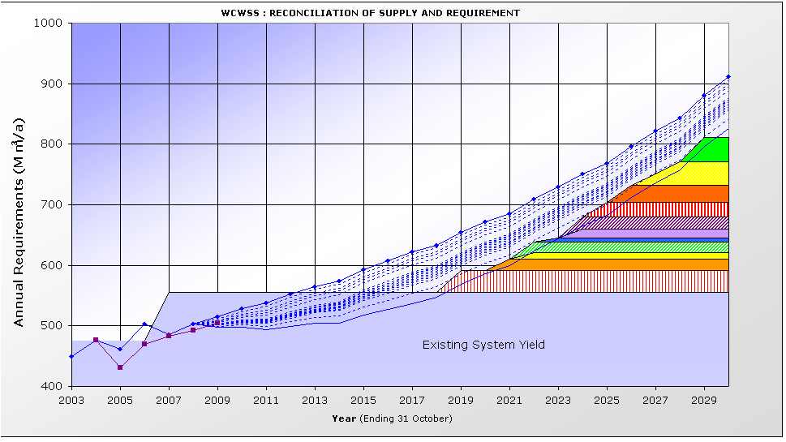
4
5
6
10
11
9
8
7
3
2
1

Figure 5: Reconciliation of Water Supply and Requirement for the Reference Scenario based on lowest URV

In Table 3 the interventions which have been used in Fig 5 are listed.
Intervention required by 2019

Table 3: 2009 Reference Scenario: Supply-side interventions that could be implemented

No | Intervention | Year of First  Water or Saving | Yield  million  m³/a | Total  Lead  Time | Study  Start  Date | Fast-  tracked
1 | Michell's Pass Diversion (4m³ s) | 2019 | 36 | 7 | 2010 | No
2 | Lourens River Diversion | 2021 | 19 | 10 | 2011 | No
3 | Upper Wit River Diversion | 2022 | 10 | 9 | 2013 | No
4 | Cape Flats Aquifer Development | 2022 | 18 | 10 | 2012 | No
5 | Newlands Aquifer Development | 2023 | 7 | 10 | 2013 | No
6 | ASR: West Coast | 2024 | 14 | 11 | 2013 | No
7 | TMG Aquifer Scheme 1 | 2024 | 20 | 10.5 | 2013 | No
9 | Upper Molenaars River Diversion (To Berg River Dam) | 2026 | 27 | 9 | 2017 | No
10 | Water Re-use Generic 1 | 2027 | 40 | 10 | 2017 | No
11 | Water Re-use Generic 2 | 2029 | 40 | 10 | 2019 | No

4.6.2 “Worst-Case” Scenario (“High water requirement”, WC/WDM 100% successful, with climate change)

The Worst-Case Scenario assumes that the CCT is still able to achieve 100% of the WC/WDM targets it has proposed for the remaining 8 years of the approved 10-year WC/WDM Strategy and Programme. This scenario also assumes that climate change will impact on the available yield of the WCWSS. Under this scenario the requirement for water would exceed the available supply in 2017. No interventions are available that would be ready by that date. Fast tracking of some of the interventions could however enable the reconciliation of supply and requirement by 2017.

Under this scenario, a number of surface water interventions which are currently being studied by the DWA (e.g. Michell’s Pass Diversion, Voëlvlei Augmentation, Upper Wit River Diversion, Upper Molenaars River Diversion) could be fast-tracked and any one implemented by 2017. Any of the interventions which are still going to be studied by the CCT, namely water re-use, seawater desalination and the Cape Flats Aquifer development, could also be fast-tracked to deliver water by 2017.

Under the Worst-Case Scenario, the DWA and the CCT would have to take a decision by mid 2011 on which interventions to fast-track in order to enable the finally chosen intervention to be designed, implemented and able to deliver its first water by 2017.

The earliest intervention which could be implemented (if fast-tracked) is the implementation of the TMG Aquifer. The TMG Aquifer has been identified as a potentially significant source of water for future supply to the WCWSS. It is, however, envisaged that any large-scale development of the TMG Aquifer will only occur upon completion of the CCT’s current initiative, and once the feasibility and sustainability of large scale abstraction for the WCWSS has been established. Fast-tracking of the TMG Aquifer development is therefore not considered as an option at this stage.

Fast-tracking of the Lourens River Diversion was also not considered an option due to the reasons stated in the Reference Scenario above.

A possible reconciliation of supply and requirement for the Worst-Case Scenario based on lowest URV is shown in Figure 6. This represents only one potential development sequence.

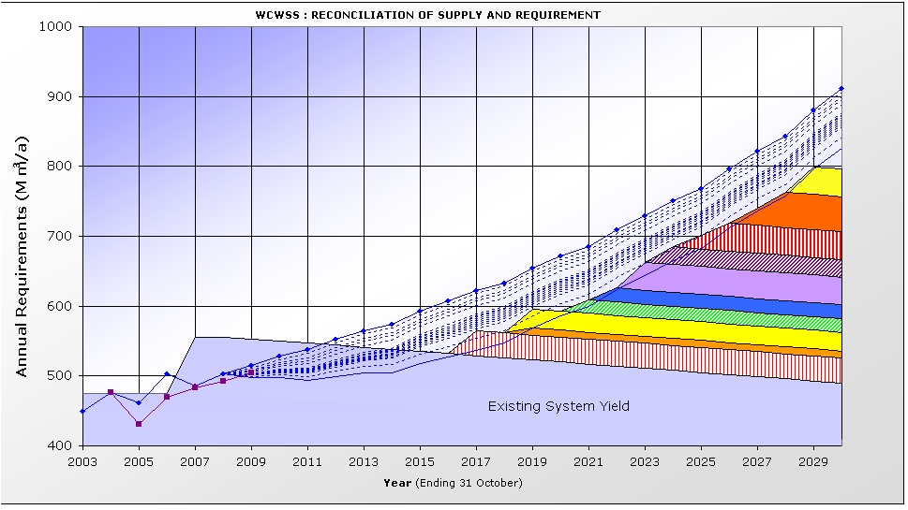
3
9
10
8
7
1
6
2
4
5

Intervention required by 2017

Figure 6: Reconciliation of Water Supply and Requirement for the Worst-Case Scenario based on lowest URV to offset the impacts of Climate Change
Table 4 lists the supply-side interventions which have to be implemented in order to ensure the reconciliation of supply and requirement up to 2030 for the Worst-Case Scenario.

Table 4: “Worst-Case” Scenario: Supply-side interventions implemented

No | Intervention | Year of First  Water or Saving | Yield  million  m³/a | Total  Lead  Time | Study  Start  Date | Fast-  tracked
1 | Michell's Pass Diversion (4m³/s) | 2017 | 36 | 7 | 2010 | YES
2 | Upper Wit River Diversion | 2019 | 10 | 9 | 2010
3 | Upper Molenaars River Diversion (to Berg River Dam) | 2019 | 27 | 9 | 2010
4 | Lourens River Diversion | 2021 | 19 | 10 | 2011
5 | TMG Scheme 1 (1 year into CCT pilot monitoring) | 2022 | 20 | 10.5 | 2011
6 | Water Re-use Generic 1 | 2023 | 40 | 10 | 2013
7 | Raise Lower Steenbras Dam | 2024 | 25 | 11 | 2013
8 | Water Re-use Generic 2 | 2025 | 40 | 10 | 2015
9 | TMG Scheme 2 (1 year into CCT pilot monitoring) | 2027 | 50 | 10.5 | 2016
10 | Desalination 1 Generic | 2029 | 40 | 10 | 2019

  - Implications Highlighted by the Scenario Planning

In the 2009 Reference Scenario, all interventions which are currently being studied could be implemented timeously in order to ensure the reconciliation of water supply and requirement by 2019. In the Worst-Case Scenario, which assumes that the yield of the WCWSS will start decreasing by 3 million m³/a over a period of 25 years as a result of climate change, a new intervention will be required by 2017 to ensure the reconciliation of water supply and requirement. In order to ensure the reconciliation of water supply and requirement by this date, it will be a requirement to fast-track a surface water intervention, water re-use or seawater desalination.

In order to enable the DWA and the CCT to decide on the most favourable intervention for implementation from 2017 onwards, it is imperative that the CCT should commence with its prefeasibility/feasibility studies of water re-use, desalination and the Cape Flats Aquifer.

The benefits of water re-use are listed below:
- Water re-use is a potentially significant resource (the yield of the intervention could be in the region of 80 million m³/a, in the same order as the yield of the Berg River Dam). A comprehensive re-use scheme has a significant yield compared to the smaller yields of potential surface water interventions.
- A water re-use intervention is not climate dependent. This would provide for a diversification strategy and would mitigate the potential risks associated with the implementation of additional surface water interventions.
- A water re-use intervention provides water in both summer and winter, whilst the potential low URV surface water interventions are run-of-river abstraction schemes (abstracting only winter water).
- Studying water re-use may be essential to get EIA approval for the next augmentation scheme.
- It will utilise “water” that would otherwise have been discharged into the sea.
- It will assist the CCT with compliance to DWA discharge standards.
- It is significantly cheaper than desalination of seawater.

It is important to undertake a feasibility study to test the “acceptability” of the proposed water re-use interventions.
The CCT’s planned pilot desalination plant will only add approximately 1 million m³/a to the supply. This quantity is too small to impact on the reconciliation of water supply and requirement and the implementation dates of future interventions. Large-scale desalination is still expected to be more expensive than a water re-use scheme. Large-scale desalination should also be investigated as it may be socially more acceptable than water re-use and represents the ultimate long-term solution for water supply to the WCWSS. The cost of large-scale desalination would also be used as a benchmark for the costs of any water supply schemes. It is therefore recommended that the CCT investigate the feasibility of large-scale sea water desalination in parallel to investigating the feasibility of water re-use. Studying desalination at pre-feasibility/feasibility level would have the following advantages:

- Energy requirements for desalination would be understood better, especially if it is linked to renewable sources of energy.
- There is a need to understand how a desalination plant would link into the Cape Town supply system.
- Implementation of a desalination plant may impact on the timing of the extension of a conventional Water Treatment Works.

By studying the abovementioned interventions and undertaking the EIAs the DWA and the CCT would be proactive in their planning and would be able to make the most appropriate choice of which intervention to implement as the next water augmentation scheme.

  - Implementation of the Ecological Reserve

The ecological Reserve from the Berg River Dam was built into the design and operational rules for the scheme and is currently being supplied. However, dams constructed prior to the Berg River Dam are not releasing the ecological Reserve requirements. Based on the 2009 Reference Scenario, it is proposed that the ecological Reserve on “older dams” should only be phased in after 2019. Should the Reserve be implemented prior to 2019, it would not be possible to implement interventions to offset the loss in yield due to environmental flow releases. The implementation of the Reserve should be phased in, in a planned manner, based on the implementation dates of future water augmentation schemes. Figure 7 illustrates a possible scenario for the implementation of the Reserve after 2019.

Figure 7: Reconciliation of water supply and requirements with phasing in of the ecological Reserve

- KEY MESSAGES

The following key messages can be taken from the comparison of water supply and requirement and the scenario planning undertaken for the September 2009 Strategy Steering Committee meeting:

Message 1: Successful implementation of WC/WDM is critical
The CCT must inform the Strategy Steering Committee if it anticipates problems in the implementation of the approved WC/WDM Strategy. The CCT must establish a monitoring programme to measure the impact of the WC/WDM interventions implemented. Should the WC/WDM strategy not be successfully implemented and the potential supply schemes not be implemented by the required dates there is a potential risk that DWA would have to impose water restrictions on the water users of the WCWSS until additional WC/WDM measures are implemented or until one of the proposed supply-side schemes is ready to deliver water.
Message 2: Re-use of water is an important option
There is a high likelihood that this option will need to be implemented as an augmentation option in later years.
Message 3: The feasibility of seawater desalination should also be investigated
It is important to study desalination in parallel to re-use of water as insurance against problems with re-use. Desalination is also seen as the ultimate future augmentation solution for the area.
Message 4: It may become important to fast track supply-side interventions
A number of studies for supply-side interventions are currently underway. A decision to fast track some of these will need to be made by 2011 should climate change become a reality or should the CCT be less successful with WC/WDM than what is expected from the implementation of the CCT’s WC/WD strategy.
Message 5: Choice of intervention will be dependent on growth in water requirement
If growth in water requirement is lower than the high water requirement curve, then it may be possible to implement the intervention with the lowest URV e.g. Lourens River. If however the water requirements keep on growing at the current rate, it is important to continue with feasibility studies of other interventions as well.
Message 6: Monitoring very important
It is important to implement a system to monitor potential indicators for climate change and to monitor the CCT’s success in implementing their WC/WDM Strategy measures.

- RECOMMENDATiONS

The following recommendations follow from the assessment of the current water requirements and updated scenario planning:

- The CCT must continue with the implementation of their 10-year WC/WDM strategy.
- The Feasibility Studies as identified in the 2007 Reconciliation Strategy Study and the 2009 Scenario Planning update need to continue or start, namely:
  - Surface water options by DWA - continue
  - Table Mountain Group Aquifer (TMG) by CCT - continue
  - Cape Flats Aquifer and Lourens River by CCT - start in next financial year.
- The CCT should urgently implement feasibility studies on water re-use and on desalination (it is anticipated that these studies will start prior to June 2010).
- A monitoring system must be put in place to serve as an early warning system should climate change start impacting on water availability and/or water requirements. A monitoring system should also be put in place to be able to quantify and measure the success of the WC/WDM interventions which are being implemented. The DWA should be responsible for monitoring water availability and the CCT should be responsible for monitoring the success of WC/WDM.
- The high water demand scenario will still be used as basis for future scenario planning. Water requirements must be monitored and the projected water requirement curves should be updated if the current assumptions used are deemed to be no longer valid.
- The Western Cape Water Supply System Reconciliation Strategy should be re-assessed in September 2010 and adjusted if required.

Appendix A

EXTENT OF WCWSS

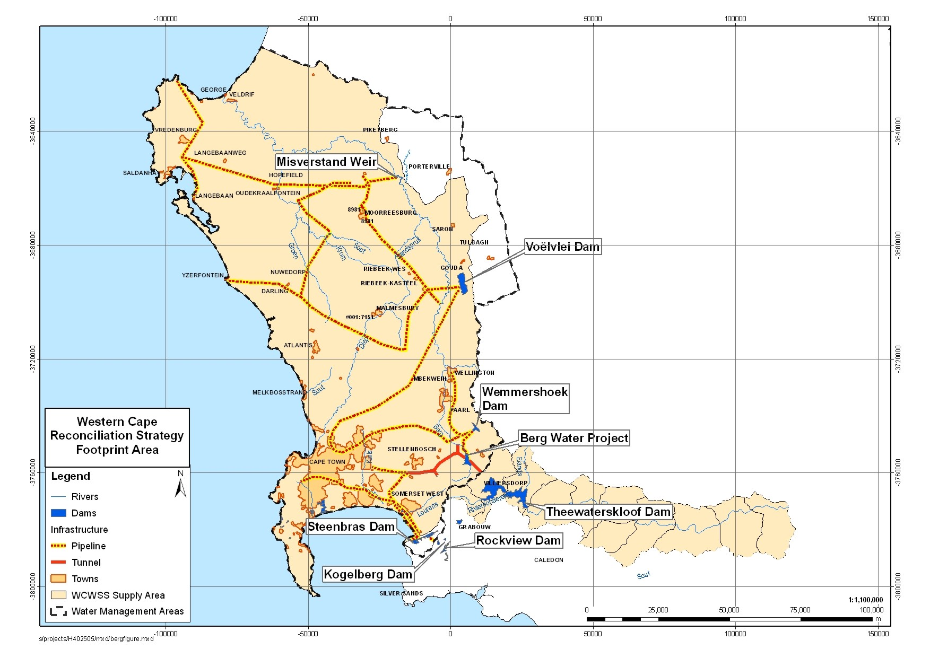

Appendix B

BACKGROUND INFORMATION ON THE WCWSS

STRATEGIC PERSPECTIVE ON WATER RESOURCES

The main storage dams of the WCWSS are the Theewaterskloof Dam, Voëlvlei Dam, Berg River Dam, Wemmershoek Dam and the Upper and Lower Steenbras Dams. The largest supply scheme of the WCWSS is the Riviersonderend Government Water Scheme (GWS), which is a large inter-basin water transfer scheme that regulates the flow of the Riviersonderend (Riviersonderend), Berg and Eerste rivers, for urban, industrial and irrigation use. The Riviersonderend GWS consists of the Theewaterskloof Dam on the Riviersonderend River and a tunnel system through the Hottentots Holland Mountains. This tunnel system conveys surplus flows in winter from the Berg River tributaries to the Theewaterskloof Dam where the water is stored. In summer, water is released back via the Riviersonderend tunnel system to the Franschhoekberg outlet, the Kleinplaas Dam on the Eerste River, and the Stellenboschberg outlet. The Berg River Dam is linked to this scheme via the Dasbos outlet. Pipelines from the Riviersonderend GWS and the other dams convey water to the water treatment plants which supply the City of Cape Town and surrounding towns with potable water.

It is the relatively large capacity of DWA’s tunnel system and of the CCT’s pipelines from these dams, as well as the flexibility of the CCT’s bulk water supply system, that enables all the major dams to be operated as an integrated system. The purpose of operating the dams as an integrated system is to prevent unnecessary spillage from any one dam, and thereby maximising water resources to the benefit of all water users.

The Berg Water Project (BWP), which was completed in 2008, also forms part of the WCWSS. This project will meet the growing water requirement until about 2013; thereafter additional demand and supply interventions will be required.

The WCWSS is situated in a winter rainfall area, characterised by wet winters and dry summers, and the dams are therefore filled during the wet winter months, from May to October, when about 90% of the annual runoff occurs. During this period the water requirement comprises only about 30% of the annual requirement. During the dry summer months, from November to April, inflows to the dams are small and irrigation and garden watering requirements in the urban areas are large. Approximately 50% of the dams’ storage volumes are required for storage during the winter so that the high water requirement during the summer can be met. The remaining 50% of the dams' storage volume is required to provide long-term carry-over storage for periods of drought.

In April 2003 DWA and CCT entered into a new agreement for the supply of raw water. The operation of the dams of the Western Cape System as an integrated system is possible because of the willingness of CCT and DWA to interpret this agreement in a cooperative manner, and because of the close collaboration between the officials from the various authorities responsible for the management of the various components of the system as described above.

Drought Management

The dams are operated in an integrated manner to minimise spillage during the wetter years and thus to maximise the stored water available for essential use during droughts. The effects of droughts are assessed with the DWA’s water resources system model and are managed by progressively restricting supplies. The Director General of the DWA imposes these restrictions after consultation with all Water User Associations (WUA) and water service providers and authorities. The DWA’s Regional Office and CCT co-operatively manage the WCWSS.

One of the main principles for optimising the operation of the Western Cape System is that the supplies to the users should be progressively restricted during periods when the demands exceed the supplies. These circumstances normally occur when supplies are reduced by droughts or when the demands outgrow the supplies before an additional source of supply is commissioned. Both of these circumstances applied to the Western Cape System when DWA imposed restrictions on its consumers in 2000 and 2004.

The normal operating rules developed for drought conditions are based on the principle that light restrictions should be applied more frequently and more severe restrictions less frequently. These restriction levels are typical for urban and industrial supplies but provide a higher level of assurance than normal for irrigation on account of the high-value permanent crops. The principle of applying increasingly more severe restrictions enables the abstractions from the system to be maximised while ensuring that the dams will never be emptied. In order to be able to implement restrictions successfully it is necessary to determine the requirements of each user and to be certain that each user can successfully implement restrictions so as to ensure that requirements are reduced as and when required.

The management of droughts is facilitated by the Western Cape Water System Consultative Forum, on which all the main stakeholder water users are represented. The Forum meets as often as may be required between June and November to decide whether to recommend to the Minister that water restriction should be imposed, and at about quarterly intervals thereafter to monitor the actual usage to be targeted by the stakeholder users.

The CCT and other Municipalities generally require at least two months advance notice of water restrictions in order to pass the necessary Council resolutions and to meet the legislative requirements of advertising the restrictions and tariff increases, and considering objections. Water tariffs are usually adjusted when restrictions are implemented so that the income from reduced water usage will be sufficient to meet the budgeted income requirements. Increased water tariffs are also an incentive for consumers to comply with restrictions.

Water Conservation and Demand Management

There are fundamental differences between drought mitigation and WC/WDM interventions and one must not confuse water restrictions with water demand management. Water restrictions are planned punitive measures to reduce water requirements in the short term and should be applied judiciously when circumstances such as droughts necessitate the implementation thereof. WC/WDM focuses on the sustained minimisation/ elimination of wastage and the optimal use of water over the medium to long term, with nominal impact on the quality of life of the consumer and invariably with financial benefits accruing to the municipality concerned.

Water is a scarce resource in the WCWSS area and it is therefore essential to use it efficiently to ensure sustainable availability and supply into the future. The National Water Act (1998) and the Water Services Act (1997) emphasise the importance of WC/WDM in support of environmental sustainability, social-economic equity and water use efficiency. The development of a water demand management strategy is also a key requirement of the Water Services Development Plans (WSDP), which are required from all Municipalities under the Water Services Act.

In 1999, the CCT initiated the Integrated Water Resources Management Study, the outcome of which clearly indicated that WC/WDM interventions are the most feasible for reconciling water requirement and supply. In 2001, CCT developed a WC/WDM Policy and Implementation Strategy. Institutional restructuring and other competing priorities between 2002 and 2004 impacted on the implementation of WC/WDM initiatives. However, in 2004 a 10-point strategy, including both output and input goals, was developed in partnership with the DWA, to augment the original 2001 WC/WDM strategy, including an 8-year budget, for implementation from 2005. However, the 2004/05 drought delayed completion of the strategy, with the focus being shifted to drought mitigation measures. The WC/WDM strategy was revised in 2006 and approved by the CCT’s Utility Services Portfolio Committee, the Mayoral Committee and full Council during May 2007. Several successful WC/WDM projects have already been implemented by CCT's Water Demand Management Branch, including pressure management projects, leak repair projects, treated effluent use and community awareness projects.

When the Minister of DWA approved the construction of the Berg Water Project, the project was approved as a parallel process to the CCT implementing WC/WDM. The City of Cape Town’s 10-year WC/WDM strategy and programme was approved in May 2007 and is currently in the process of being implemented.

Use of treated effluent

At present, about 60% of all the water used by CCT enters the sewer networks as wastewater. This wastewater is then treated and either re-used (currently estimated to be about 10%) or is discharged to the sea as treated effluent (currently 90%). The treated effluent that ultimately ends up in the sea is often disposed of through rivers and wetlands, with significant environmental impact.

Treated effluent is a valuable resource and needs to be integrated into the overall reconciliation process of water supply and requirement. Currently the 16 wastewater treatment works (excluding sea outfalls) in the City of Cape Town discharge approximately 500 Mℓ/day (184 Mm³/a) into rivers and directly into the sea. This far exceeds the estimated yield of any of the prospective water resource schemes under consideration. The peak daily summer re-use is estimated to be approximately 80 Mℓ/day, or approximately 21 Mm³/a. This represents 18.6% of the daily dry weather flow and approximately 13.3% of the annual volume (figures obtained from “Treated Effluent Re-use Strategy and Master Planning within the City of Cape Town. April 2007”).

Various studies have been done over the years, all of which point to the significant potential available in the re-use of water. The information contained in the study reports needs to be synthesised, updated and integrated into a comprehensive Strategic Assessment that can be used as a springboard for action and implementation.

A strategic assessment of the water re-use potential to augment the Western Cape Water Supply System was undertaken by DWA in January 2009. The conclusion of this study was that there is a significant potential for water re-use as a major intervention to augment the WCWSS and that planned indirect potable re-use should be considered as the preferred way to implement a water re-use scheme. The assessment further recommended that a detailed feasibility study be undertaken by the City of Cape Town so that a comparative assessment of water re-use against other potential water resource development options could be undertaken.

Potential for Climate Change

The WCWSS Reconciliation Strategy Study considered the potential impact of climate change on the longer term reconciliation of supply and requirement. The scenario planning assumed that the yield of existing surface water resource schemes would decrease by approximately 15% over the next 25 years. Professor Hewitson of the Climatology Department of the University of Cape Town gave a presentation to the Strategy Steering Committee in March 2009 on the potential implications of climate change on the WCWSS. Whilst the climatology models still need to be refined, there will be a general trend towards higher temperatures and a decrease in precipitation in general in the Berg and Breede Water Management Areas. Drought events may become more regular and also extend for longer periods. The intensity of drought and flood events would also increase. Professor Hewitson confirmed that the assumptions made in the scenario planning undertaken as part of the WCWSS Reconciliation Strategy were realistic.

Appendix C

REPRESENTATION ON THE STRATEGY STEERING COMMITTEE

WESTERN CAPE STRATEGY STEERING COMMITTEE REPRESENTATION

ORGANISATION | ADDRESS
National Government
Department of Water Affairs (Head Office) | Private Bag X313, Pretoria 0001
Department of Water Affairs (Regional Office) | Private Bag X16, Sanlamhof 7532
Western Cape Provincial Government
Department of Agriculture | P/Bag X1 Elsenburg 7607
Department of Local Government and Housing | P/Bag X9083 Cape Town 8000
CapeNature | P/Bag X29 Rondebosch 7701
Dept of Environmental Affairs and Development Planning | P/Bag X9086, Cape Town 8000
- Planning Branch
- Environmental Branch
Local Authorities
City of Cape Town | PO Box 16548 Vlaeberg
- Bulk Water
- Waste Water
- WC/WDM
West Coast DM | PO Box 242, Moorreesburg 7310
Cape Winelands DM | PO Box 91, Worcester 6849
Drakenstein | PO Box 1, Paarl, 7620
Stellenbosch | PO Box 17, Stellenbosch
CMAs
Berg | Not yet established
Breede-Overberg | Private Bag X3055 Worcester 6850
WUAs
Berg WUA | PO Box 540, Wellington 7655
Breede-Overberg WUA | PO Box 232, Robertson 6705

Appendix D

UPDATED WATER REQUIREMENTS

Current Water Requirements

Figure 1 shows the CCT’s annual bulk water supplied over the 30-year period from 1978 to 2008, with the high and low water requirement curves and the projected impact of the CCT’s 10-year WC/WDM strategy. The starting point for the high and low water requirement curves was adjusted based on the 2008 actual water requirements. This decision was taken by the Strategy Steering Committee at the meeting held in September 2008. The high and low water requirement curves were derived during the WCRSS.

Figure 1: Bulk Water Supplied by the CCT

The bulk water supplied by the CCT in their 2007/2008 financial year was 315.7 million m³/a, and in their 2008/2009 financial year 324.4 million m³/a. This represents an increase of approximately 2.7% per annum. The average increase in the CCT’s winter water requirements during the months of June, July and August increased by 5% from 2008 to 2009. This shows that there is still an underlying growth in the water requirement in the Cape Metropolitan Area.

A determination of the water requirement from the WCWSS was undertaken based on the actual urban and agricultural water requirements in the 2008/2009 hydrological year (this runs from October 2008 through to September 2009). Estimates were made for August and September 2009, where the water requirement information was not yet available. The agricultural water use was lower than the projected use due to good rainfall. The so-called “adjusted actual” curve where urban and agricultural use are summed, shows the actual for urban use added to the projected use for agriculture. Figure 2 shows the actual urban and agricultural water requirements from the WCWSS as well as the “adjusted” actual water requirement of 505 million m³/annum.

In the text of the main Report, the adjusted actual water curve is referred to as the actual water curve.

Figure 2: Water Requirements from the WCWSS

A comparison between the “adjusted” actual water requirement from the WCWSS and the high water requirement curves developed during the Reconciliation Strategy Study (refer to Figure 3) shows that the adjusted actual water requirement falls just below the high water requirement curve. The adjusted actual water requirement from the WCWSS is greater than the projected water requirement curve for 2009 when taking into account the implementation of the WC/WDM interventions planned by the CCT for this period. This could be as a result of a higher than anticipated growth in water requirement (i.e. higher than the high water requirement curve) or a less than 100% success in the implementation of WC/WDM or a combination of these two factors. The adjusted actual water usage from the WCWSS for 2009 amounted to approximately 505 million m³/a, compared to the available yield of the existing WCWSS, with the inclusion of the Berg Water Project, of 556 million m³/a.

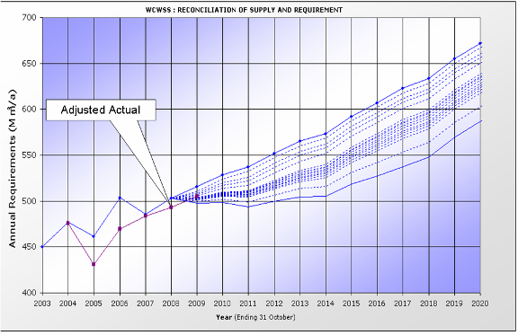

Figure 3: Adjusted Actual and Projected water requirement from the WCWSS

Appendix E

INTERVENTION IMPLEMENTATION PROGRAMME

Michell's Pass Diversion (4m3/s) |  | YEARS - NORMAL PROGRAMME
 |  | 1 |  | 2 |  | 3 |  | 4 |  | 5 |  | 6 |  |  | 7 |  |  | 8 |  |  | 9 |  |  | 10 |  |  | 11 |  |  | 12 |  |  | 13
 |  | 2009 |  | 2010 |  | 2011 |  | 2012 |  | 2013 |  | 2014 |  |  | 2015 |  |  | 2016 |  |  | 2017 |  |  | 2018 |  |  | 2019 |  |  | 2020 |  |  | 2021
Pre-feasibility
Feasibility (years)
Feasibility Study/ EIA
DWAF Reserve determination
Construction/Implementation (years)
Lag time (approvals and budget delay)
TOR / Appoint Consultant
DWAF licensing process (Reserve)
DEA&DP approval process
Design
tender prepar. & award
Construct
 |  | YEARS - FAST TRACKED
 |  | 1 |  | 2 |  | 3 |  | 4 |  | 5 |  | 6 |  |  | 7 |  |  | 8 |  |  | 9 |  |  | 10 |  |  | 11 |  |  | 12 |  |  | 13
 |  | 2009 |  | 2010 |  | 2011 |  | 2012 |  | 2013 |  | 2014 |  |  | 2015 |  |  | 2016 |  |  | 2017 |  |  | 2018 |  |  | 2019 |  |  | 2020 |  |  | 2021
Pre-feasibility
Feasibility (years)
Feasibility Study/ EIA
DWAF Reserve determination
Construction/Implementation (years)
Lag time (approvals and budget delay)
TOR / Appoint Consultant
DWAF licensing process (Reserve)
DEA&DP approval process
Design
tender prepar. & award
Construct

Water Re-use Study |  | YEARS - NORMAL PROGRAMME
 |  | 1 |  | 2 |  | 3 |  | 4 |  | 5 |  | 6 |  | 7 |  | 8 |  | 9 |  | 10 |  | 11 |  | 12 |  | 13
 |  | 2009 |  | 2010 |  | 2011 |  | 2012 |  | 2013 |  | 2014 |  | 2015 |  | 2016 |  | 2017 |  | 2018 |  | 2019 |  | 2020 |  | 2021
TOR / Appoint Consultant
Pre-feasibility
Feasibility (years)
Feasibility Study/ EIA
DWAF Reserve determination
Construction/Implementation (years)
Lag time (approvals and budget delay)
TOR / Appoint Consultant
DWAF licensing process (Reserve)
DEA&DP approval process
Design
tender prepar. & award
Construct
 |  | YEARS - FAST TRACKED
 |  | 1 |  | 2 |  | 3 |  | 4 |  | 5 |  | 6 |  | 7 |  | 8 |  | 9 |  | 10 |  | 11 |  | 12 |  | 13
 |  | 2009 |  | 2010 |  | 2011 |  | 2012 |  | 2013 |  | 2014 |  | 2015 |  | 2016 |  | 2017 |  | 2018 |  | 2019 |  | 2020 |  | 2021
TOR / Appoint Consultant
Pre-feasibility
Feasibility (years)
Feasibility Study/ EIA
DWAF Reserve determination
Construction/Implementation (years)
Lag time (approvals and budget delay)
TOR / Appoint Consultant
DWAF licensing process (Reserve)
DEA&DP approval process
Design
tender prepar. & award
Construct

TMG Aquifer Study |  | YEARS - NORMAL PROGRAMME
 |  | 1 |  | 2 |  | 3 |  | 4 |  | 5 |  | 6 |  | 7 |  | 8 |  | 9 |  | 10 |  | 11 |  | 12 |  | 13
 |  | 2009 |  | 2010 |  | 2011 |  | 2012 |  | 2013 |  | 2014 |  | 2015 |  | 2016 |  | 2017 |  | 2018 |  | 2019 |  | 2020 |  | 2021
Exploratory Phase
CCT Decision
Pilot Phase and EIA
Monitoring of Pilot Wellfield
Feasibility (years)
Lag time (approvals and budget delay)
TOR / Appoint Consultant
Feasibility Study/ EIA/design
DWAF Reserve determination
DEA&DP approval process
Construction/Implementation (years)
tender prepare. & award
Construct
 |  | YEARS - FAST TRACKED
 |  | 1 |  | 2 |  | 3 |  | 4 |  | 5 |  | 6 |  | 7 |  | 8 |  | 9 |  | 10 |  | 11 |  | 12 |  | 13
 |  | 2009 |  | 2010 |  | 2011 |  | 2012 |  | 2013 |  | 2014 |  | 2015 |  | 2016 |  | 2017 |  | 2018 |  | 2019 |  | 2020 |  | 2021
Exploratory Phase
Feasibility (years)
CCT Decision
TOR / Appoint Consultant
Feasibility Study/ EIA/design
DWAF Reserve determination
DEA&DP approval process
Construction/Implementation (years)
tender prepare. & award
Construct

